Title: Instrument – create and hire | Category: 10. Student Administration
Last update: 06-01-2017 14:13 | Author: Krestina
Language: English | Keywords:

Create and hire out an instrument

Creating an instrument
Go to SEARCH – INSTRUMENT and click “create new instrument”.
Fill in the form and finish by clicking “create”
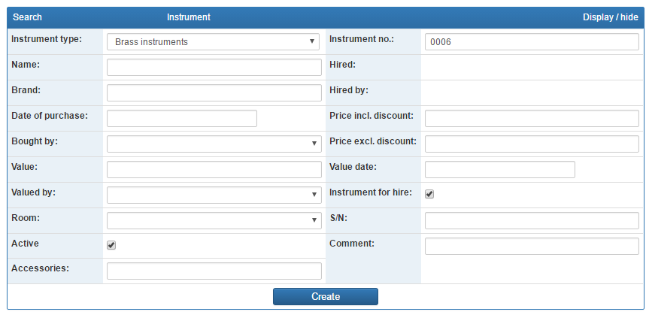
This is also where you can keep track of a potential repair history as well as add notes about an instrument

Hiring out an instrument – starting with the instrument
You can hire out an instrument by finding the instrument or the hirer first.
Starting with the instrument go to SEARCH – INSTRUMENT and select the instrument by clicking “select” on the right hand side of the screen or by clicking on the instrument number.
Click “hire”.

Fill in the hire date, whether it is “free of charge” and if not, whom the payer is.
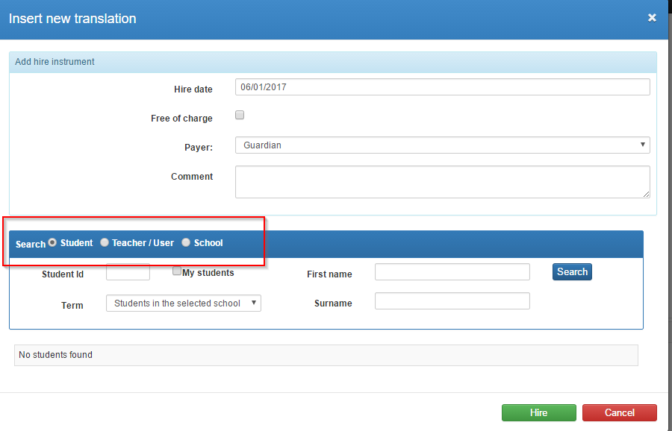
Now search and find the student, teacher/user or school that is going to hire the instrument and complete the process by clicking “Hire”.

Hiring out an instrument – starting with the student (or user)
In order to start the process with the student, go to SEARCH – STUDENT and find the correct student.
Click the tab “Hired Instruments” (1) and then “Add hire instrument” (2).
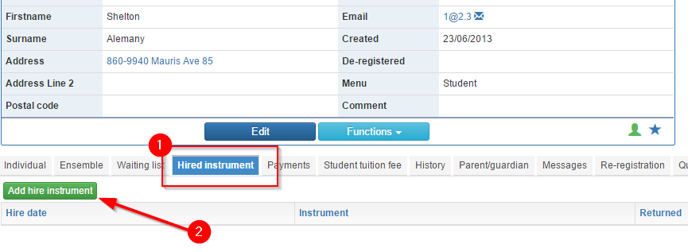
Fill in the form and finish by clicking “save”.

