Title: Instrument return | Category: 10. Student Administration
Last update: 06-01-2017 15:19 | Author: Krestina
Language: English | Keywords:

Instrument return

Returning an instrument
In order to return an instrument go to SEARCH – STUDENT and select or search for the right student.
Select the tab “Hired Instrument”
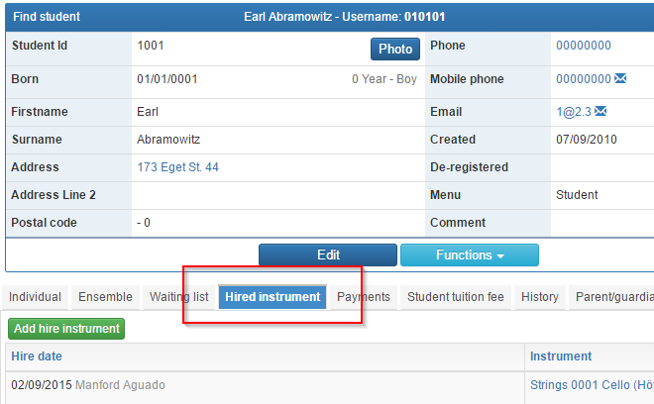

Click “Returned” on the right hand side of the screen.
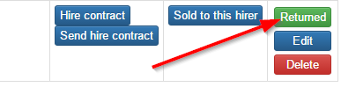
… and remember to delete any associated payments!

