Titel: Startpage | Kategori: User Manual
Sidste opdatering: 03-01-2017 15:48 | Forfatter: KBJ
Sprog: English | Nøgleord:

Start page

Start page
The start page provides you, the super user, with an overview of relevant information e.g.
- Recent and coming cancellations
- A list of students waiting to be approved
- The latest students and teachers you’ve looked at
It is possible to configure the start page to match your needs under “Settings” – see separate user manual.

The short cuts in the top right and bottom left corners are accessible from all pages in Speedadmin, see red arrows on screen shot.
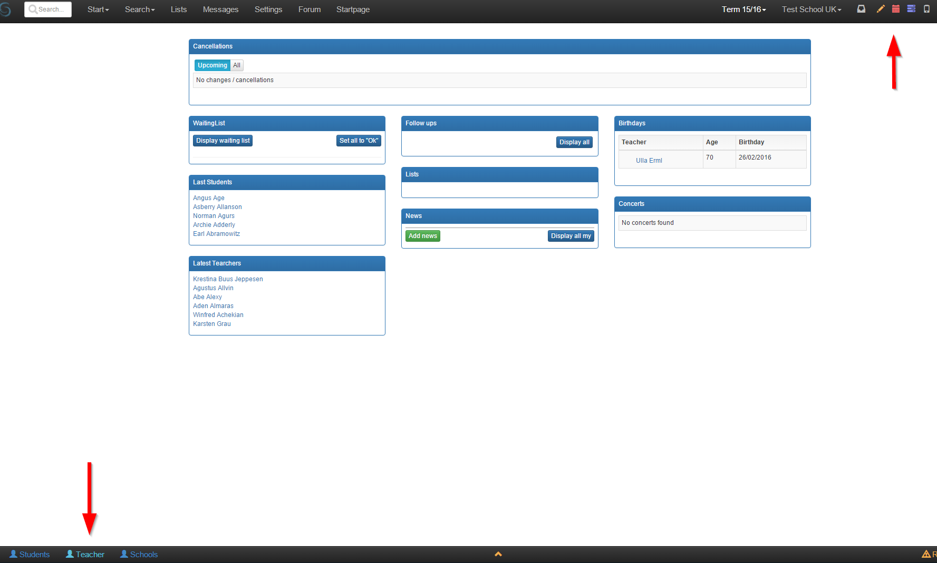

In the top right corner “Notifications” will provide you with a list of:
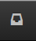
- New Students
- Payments not approved
- Students who wish to de-register

The remaining icons are short cuts to
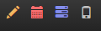
- Edit timetable
- Timetable
- Lessons
- Mobile app
This allows you to quickly access all relevant information about any given teacher that you are currently looking at in the system.

The short cuts in the bottom right corner allows you to quickly access the students, teachers and schools you have looked at most recently.
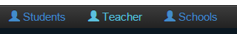

Settings
Settings is your portal for maintaining all master data. This is where you create new courses, handle payments, set school term dates etc.

