Title: Attendance list_Registering student attendance | Category: 1. Set-up
Last update: 03-01-2017 11:48 | Author: Krestina
Language: English | Keywords:

Attendance list – registering student attendance

Online registration of attendance

Go to LISTS – ATTENDANCE and select the period, weekday and courses, that you want to display the list for.
It is possible to include various contact information about the student – this is helpful if e.g. you need to contact a student who doesn’t show up for an ensemble.
When you want to take attendance you simply click the field until the correct reason for absence is shown. If the field is left blank, the student attended the class as expected.
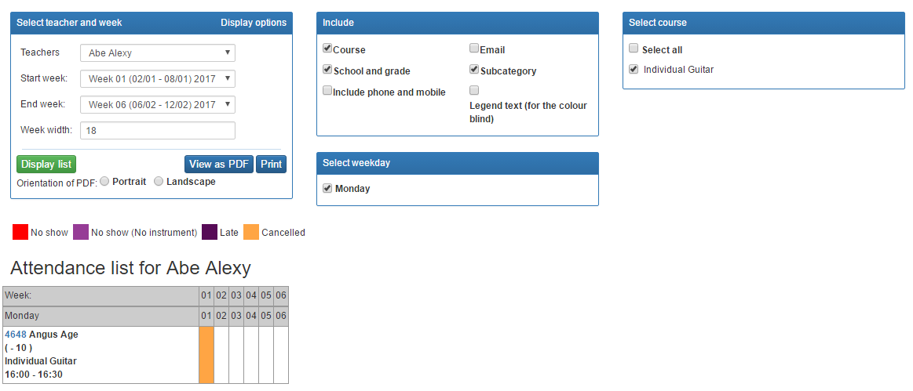
Please note, that the attendance list is only used to register students’ attendance. The function has no influence on the teacher’s lessons or registered working hours.

