Title: Attendance list set-up | Category: 1. Set-up
Last update: 03-01-2017 10:18 | Author: Krestina
Language: English | Keywords:

Attendance list – set up

Defining the reasons for students’ absence
Online registration of attendance requires a few simple but essential considerations and settings.
Under SETTINGS –> REASONS FOR ABSENCE you can type in the different reasons for a student not showing up e.g. no show, sick, cancelled due to a legitimate reason etc.
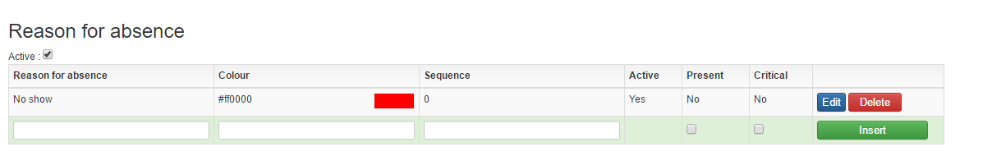
These are the “reasons” that teachers can tick-of when filling in the attendance list.
You can register as many different reasons for absence as you wish, however, we advice you to keep the number to a minimum in order to reduce the number of clicks for teachers.
When a teacher registers attendance, he/she selects the reason for absence by clicking through the sequence of reasons, which you have defined above, until the right reason appears
(see separate guideline “Attendance list – registering student attendance”).
Colour – this defines the colour of the reason for absence in the attendance list. Sick is often marked with red.
Click the desired colour on the palette and select it by clicking the icon in the bottom right of the screen (marked with a red arrow).
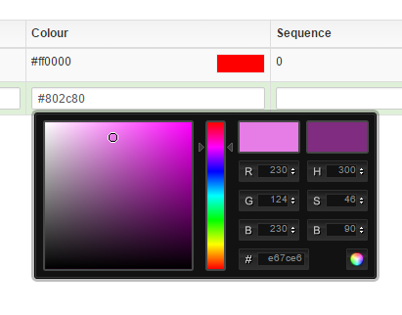

Sequence – determines the order in which the reasons appear.
Active – by marking “Active” you can extract lists based on attendance for analytical purposes.
Present – if you don’t mark “Present”, all the student’s attendance will appear under his/her master data. If you do mark “Present” only the times when the student has been absent will appear under LIST OF ATTENDANCE.
Critical – this allows you to indicate potential critical reasons for absence e.g. “no show”.

Please note, that the attendance list is only used to register students’ attendance. The function has no influence on the teacher’s lessons or registered working hours.

Start page overview
It is possible to get an overview of all attendance lists directly on your start page. Go to SETTINGS – START PAGE and select “Super user start page” and “Design”. Here you can add the category “Recent student cancellations”.
If you have included this function in your start page, it is possible to view student absence over the last 1, 3 or 6 months sorted by all reasons for absence or by the reasons you’ve marked as critical.
