Title: Course and course type | Category: 1. Set-up
Last update: 20-12-2016 13:14 | Author: Krestina
Language: Sprog: English | Keywords:

Course and course type

Administer current courses
You can view all courses via SETTINGS – COURSE. The overview can be sorted by “Course”, “Public text”, “Active” as well as number of students associated.
It is possible to view all active or inactive courses by ticking “Active” in the top of the screen.
By ticking “editable” in the top of the screen, you can edit “Department – Category” and the status “Active”.
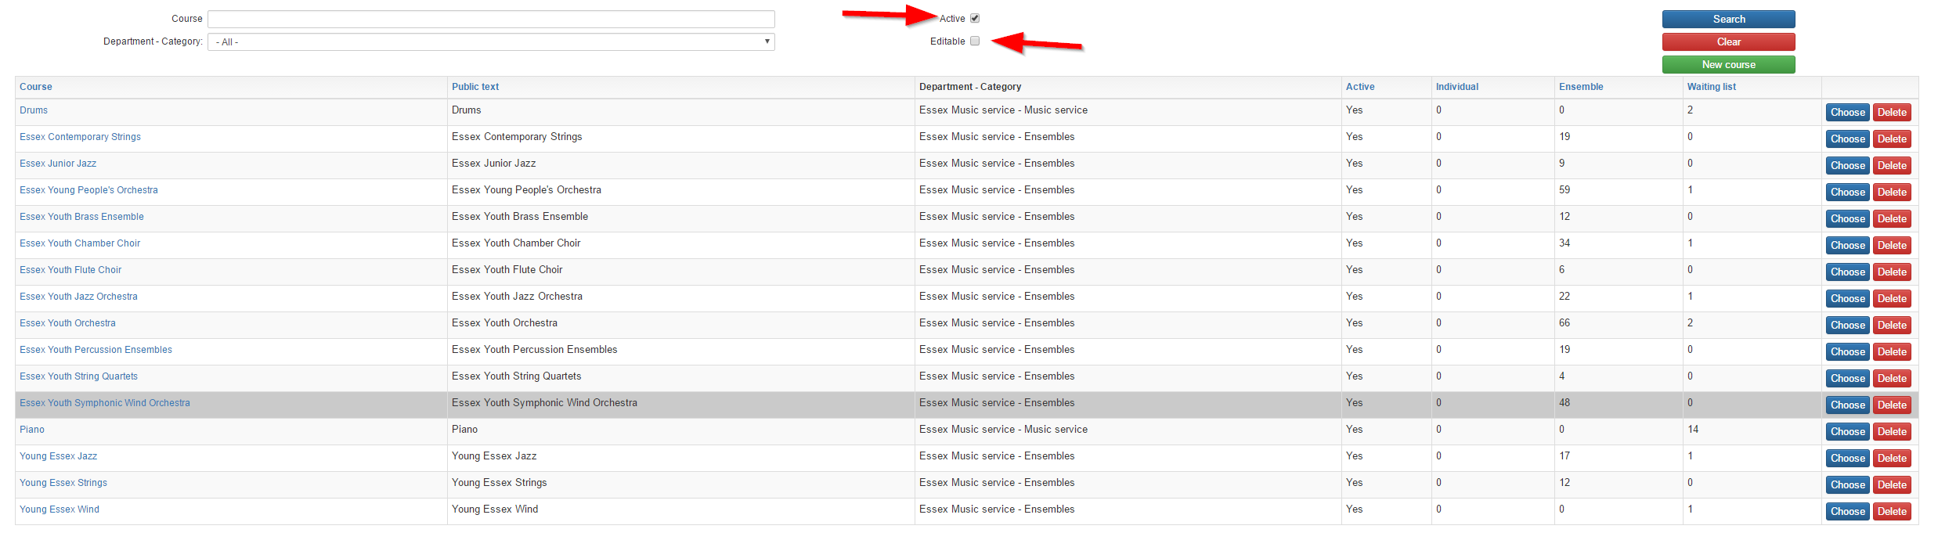
Individual = number of individual students on the course in the current school year.
Ensemble = number of ensemble students on the course in the current school year.
Waiting list = number of students on the waiting list for this course.
You can edit each course by clicking on the name of the course or on the “select” icon on the right hand side.

Creating a new course
When you want to create a new course, go to SETTINGS – COURSE and click “new course”.
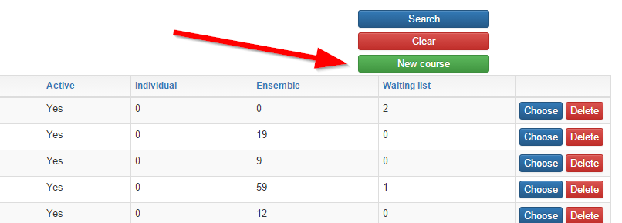

Key in the following information:
- Name (internal name)
- Public name (as it will show upon registration)
- Department – Category (from the drop-down list)
- Registration fields (from the drop-down list)
- Course code (if relevant)
- Holiday plan (if you operate with more than one)
Finish by clicking “create”.
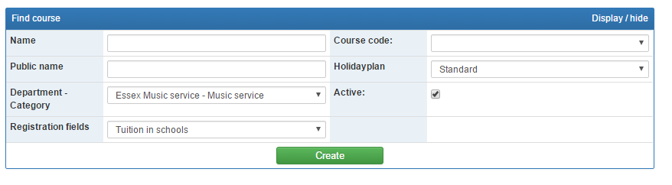
Complete the registration by adding the “Course type”. For each type please decide:
- The number of minutes and lessons. For ensembles you can change this when creating the ensemble subsequently.
- Whether the course shall be open for registration and re-registration or whether you will add students to it internally.
- Tuition fee. Tuition fees are created under SETTINGS – TUITION FEE.
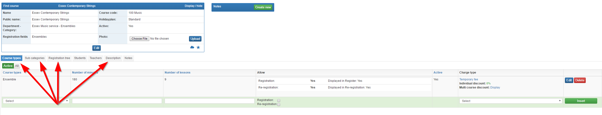
Sub category enables students to choose e.g. spring, summer or autumn term. Sub categories can either be defined by inserting standard sub categories or a free text.
Registration tree determines the course place upon registration. It is possible to add several places for the same course.
Description and photo. It is possible to add a description of the course as well as a photo, which is shown upon registration under “read more” and / or on your website via web-services.

Course Type
Under SETTINGS – COURSE TYPE you define the different types of teaching, which go across the various courses e.g. ensemble, individual 20 minutes, individual 30 minutes etc.
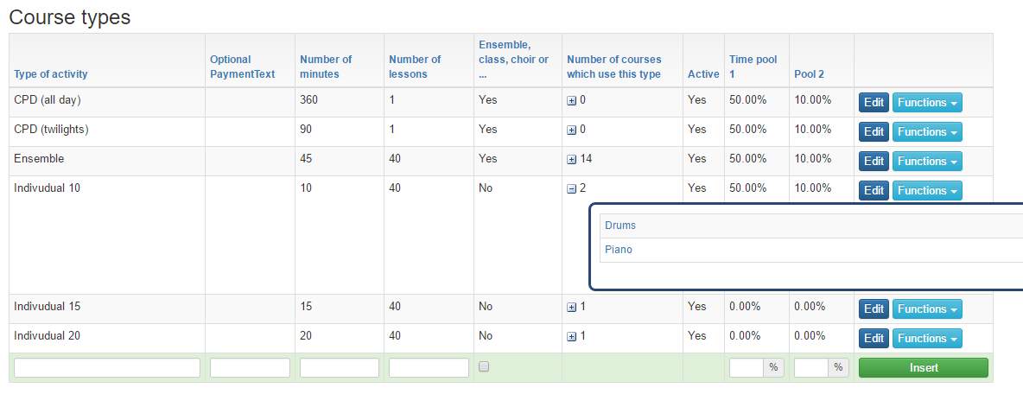
The defined number of minutes and lessons can be changed subsequently under each course / ensemble.
Ensemble, class, choir etc. are defined as classes where the number of minutes are fixed regardless of the number of students in the class.
Solo. If “Ensemble, class, choir etc.” are de-selected, the number of minutes will follow the student. This means that two students who are subseqently connected via the teacher’s time schedule will have double time, if they both are registered on an individual course.
Hence it is very important to define the course types correctly up front

