Title: Messages and email templates | Category: 5. Communication
Last update: 05-01-2017 11:57 | Author: Krestina
Language: Sprog: English | Keywords:

Email templates

Creating a template
1. Go to SETTINGS – EMAIL TEMPLATES.
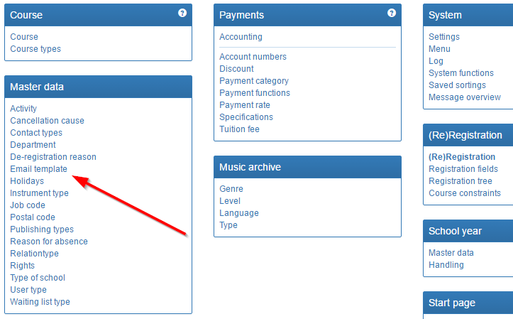
2. Create a new template – possibly by copying one of the existing ones as a starting point.
3. Click the “Merge Fields” icon marked with the arrow.
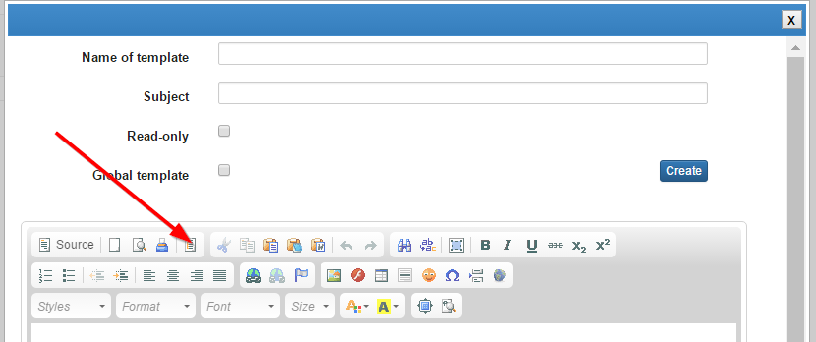

This allows you to insert information, which automatically will merge with user specific information such as
- Name
- Course
- Date and time of course
- Etc.
Hence all recipients will see their specific name, course and information in their email.

Editing a template
Email templates can be edited via the menu described above.
You can also go to MESSAGES, create a new message and “save” the edited template or create a new template by clicking “save as”.
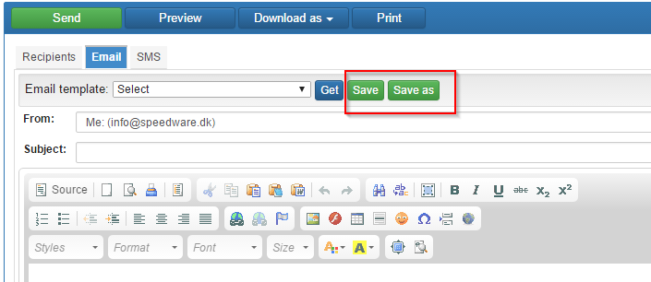

If you select a recipient, you can see the email with the correctly filled in information under “preview”.

