Title: Insert Picture in Messages | Category: 5. Communication
Last update: 05-01-2017 11:54 | Author: Krestina
Language: Sprog: English | Keywords:

Insert picture in messages

Insert a picture in a standard email signature
1. Go to SETTINGS – SYSTEM SETTINGS and select “photo”.
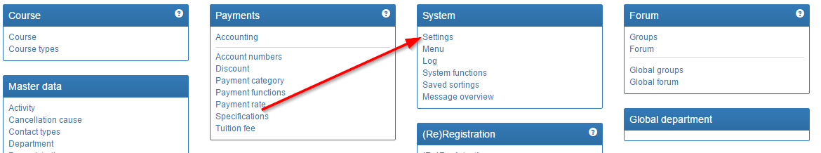

2. Upload the photos you wish to use to the local picture archive.
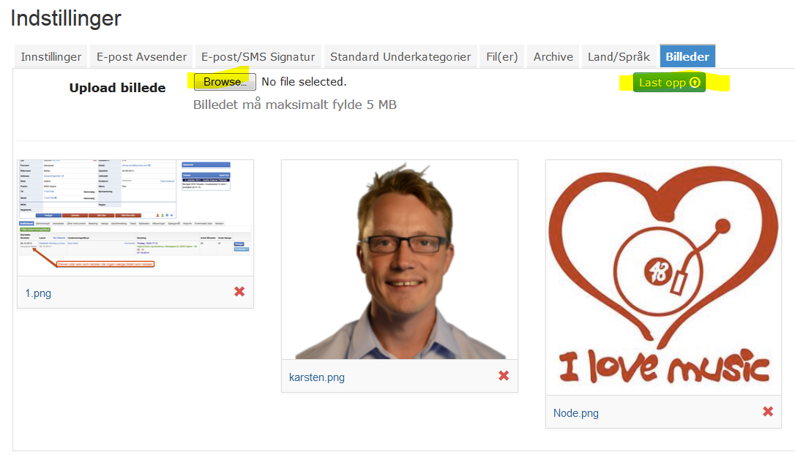
3. Right click on the photo and select “copy link address”.

4. Go to MESSAGES and select or create your message. Click the image icon.
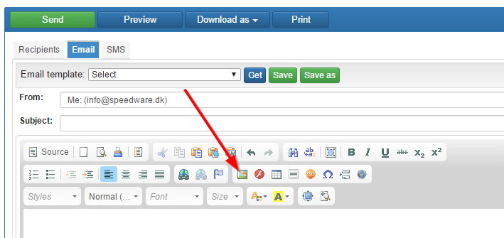

5. Insert the address into the URL and click OK.
