Title: Create and book external users | Category: 6. Activities / Booking
Last update: 06-01-2017 12:02 | Author: Krestina
Language: English | Keywords:

Create and book external users

Create external user(s)
Go to SEARCH – USER and click “new users”.
Fill in the form and remember to select “External User” in both menu and User type

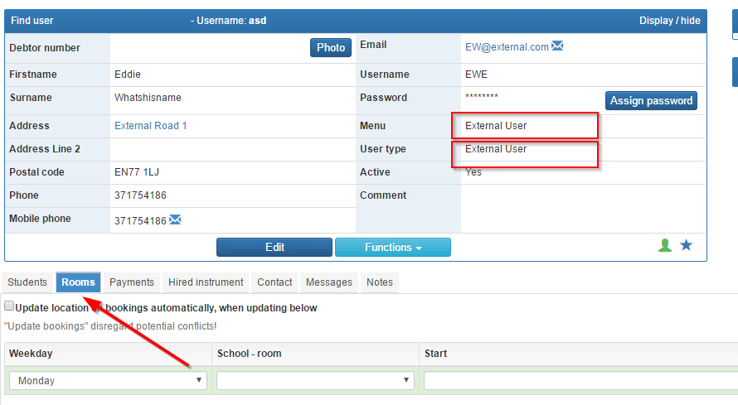
It is possible to assign a room to an external user on a weekly basis in the same way that you assign rooms to a teacher.

Book activities for external users
There are several ways to book activities for external users.
- SEARCH - ROOM – choose school and find the room you want to book. Click “display timetable” to the right on the screen and create a booking on the desired day using the “create new booking” icon . Finish by clicking “create new booking” at the bottom.
- START – ROOM OVERVIEW – find an available room and create the booking as described in bullet 1.
- START – CONCERT – CREATE. You can change this from concert to another “booking type”.
If your booking method is bullet no 3, you must remember to select a room subsequently!

Select the correct booking type e.g. external user and fill in the form.
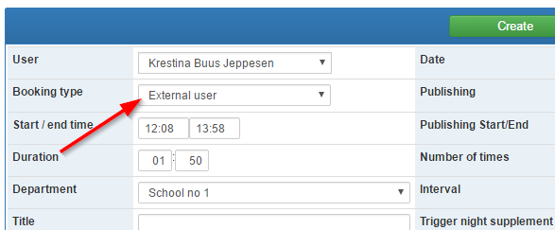
Finish by clicking “create”.
Now you can add users to your booking.
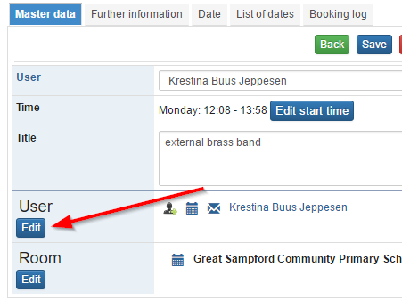
It is possible to filter users by “rights group” or by “user type” e.g. external user.
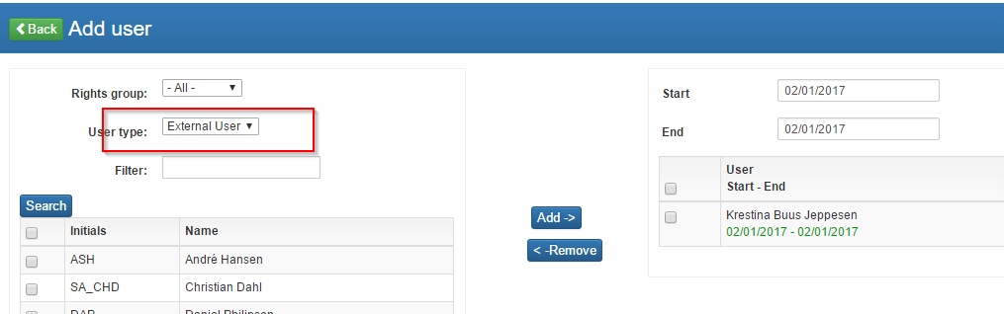
Click “back” and “save”.

