Title: Send Messages and Merge Fields | Category: 5. Communication
Last update: 05-01-2017 11:39 | Author: Krestina
Language: Sprog: English | Keywords:

Create and send messages incl. merge fields

Sending SMS and emails via Speedadmin
Go to MESSAGES – NEW MESSAGE and decide if you want to send an SMS and/or an email in the top right corner.
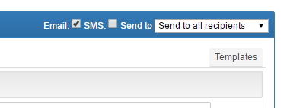

Choose recipients
Also in the top right corner you define if you want to send to the payer, the student or the parent/ guardian only – or to all three groups.
Under “recipients” on the left hand side of the window, you can search and find students via various filters or you can select the students first and then go to “messages”.
You can select students/teachers/users to send messages to via lists, student overview, teacher overview, timetable, student master data card etc.
Simply click the blue envelope icon, which appears throughout Speedadmin.
This icon takes you directly to MESSAGES.

Creating the message
Preview – allows you to view the final content if you have used merge fields and selected a recipient
Download – either as a Word or PDF file
From – be aware from whom you send the message. “From” defines the inbox where replies will be sent to.
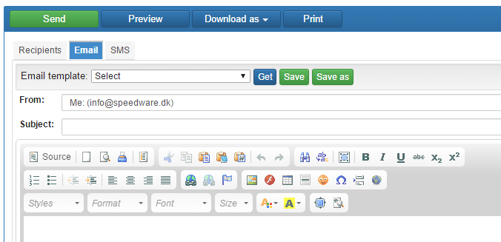
Type your text in either “Email” and/or “SMS”. You can use one of the pre-defined templates – see also guideline “Messages and Email Templates”.
You can find your drafts under MESSAGES.
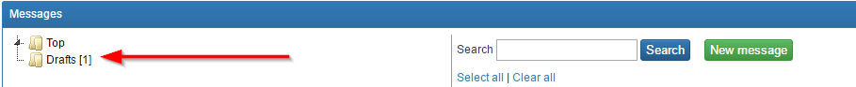
Drafts are automatically saved but only in the current session!

Merge Fields
Click the “Merge Fields” icon marked with the arrow.
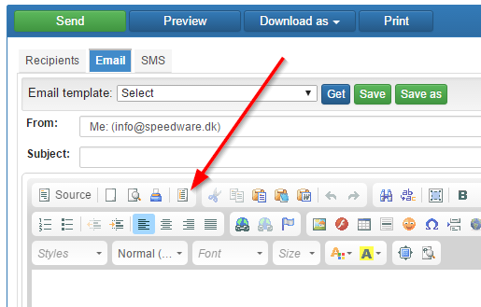
This allows you to insert information, which automatically will merge with user specific information such as
- Name
- Course
- Date and time of course
- Etc.
Hence all recipients will see their specific name, course and information in their email.
If you select just one recipient, you can see the result under “preview”.

