Title: Cancel and reschedule tuition | Category: 9. Teacher functions
Last update: 10-01-2017 13:04 | Author: Krestina
Language: English | Keywords:

Cancel and reschedule tuition

Set up cancellation cause
Go to SETTINGS – CANCELLATION CAUSE and edit or insert a cancellation cause.
For each line you define whether the cancellation cause requires a rescheduling of the booking and whether it triggers reimbursement for the student.
If a booking is cancelled and rescheduled it will not trigger reimbursement!
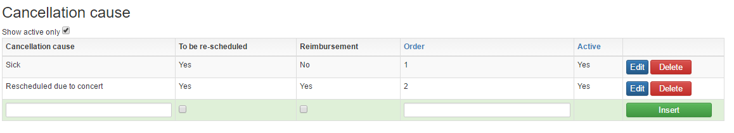

Cancel tuition
Cancelling tuition in Speedadmin is done via “timetable”.
Go to the teacher’s TIMETABLE and make sure you have selected the correct week.
- Click the red-circle icon on the right-hand side of the timetable.
- Use the left mouse button to select the students and/or ensembles that are to be cancelled (all selected bookings will turn dark grey).
- Click ”cancel booking” at the bottom of the page.

If you have accidentally included too many students or ensemble bookings in the cancellation, it is possible to remove them individually at the bottom of the page now.
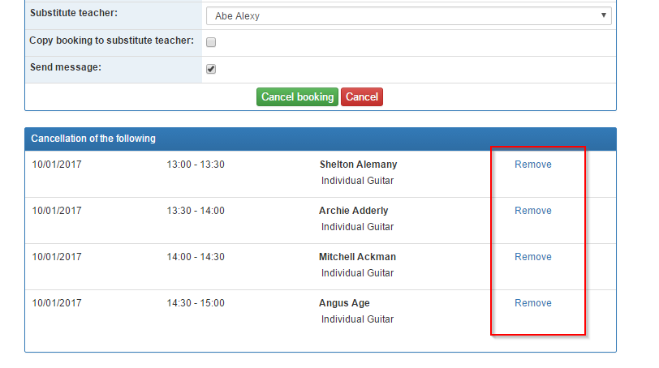
Select a cancellation cause.
- Type in an internal comment – this is visible internally in the organisation only.

- Copy or type in a public comment – this is visible externally i.e. to students or parents who log on to Speedadmin.

- It is possible to indicate a substitute teacher – this will copy all student information to the substitute teacher.
It is also possible to copy the bookings of the students. If bookings are not copied, the substitute teacher must drag and drop the students into his/her timetable via “Edit timetable”.

- Make sure to tick “Send message”, in order to be able to inform the students of the cancellation.
Click “cancel booking” to finish.
Be careful not to cancel tuition that has more than one teacher associated. The other teacher may carry out the tuition as planned.

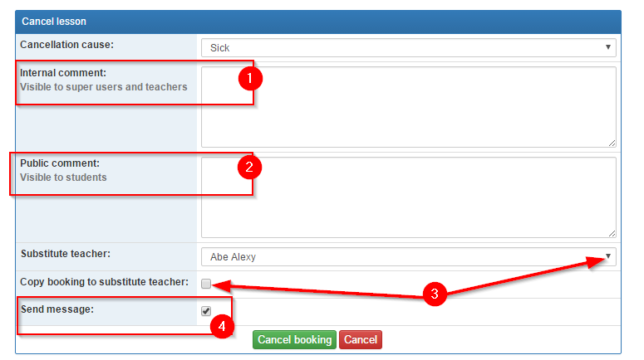

From “messages” you can inform all students and/or parents of the cancellation via sms or email.
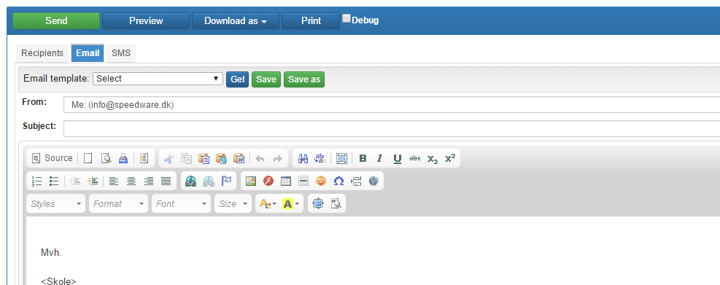

Reschedule bookings
In order to reschedule a booking go to either:
- “Timetable” and click the green circle on the right hand side or
- “Edit timetable”

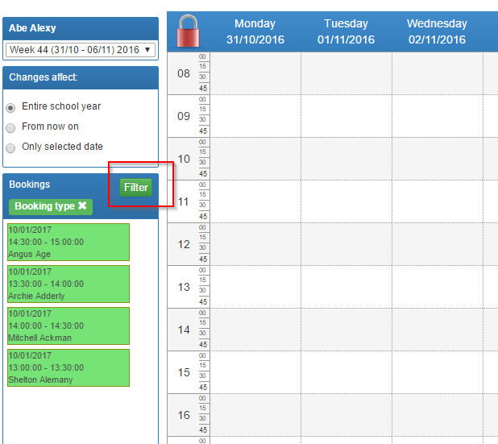

Students or ensembles to be rescheduled appear on the left-hand side in green.
Make sure that “booking filter” on the right-hand side has “All” ticked. It is also possible to select a specific date.

If you have an available room assigned to you, you can just drag and drop the bookings.
Remember to un-lock the timetable with the red/green padlock in the top left corner.

Find an available room for your rescheduled booking
If you do not have an available room, you can find one via the needle-eye icon on the right-hand side in “Edit timetable”.
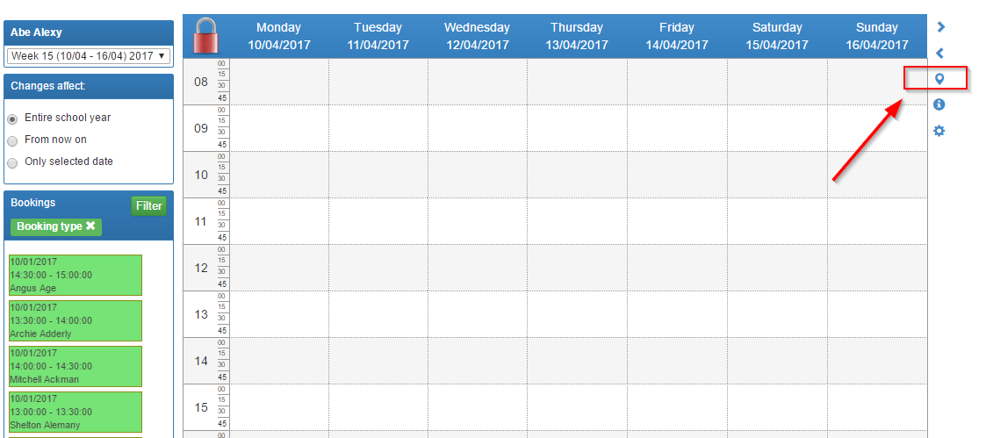

Click a room to select it.
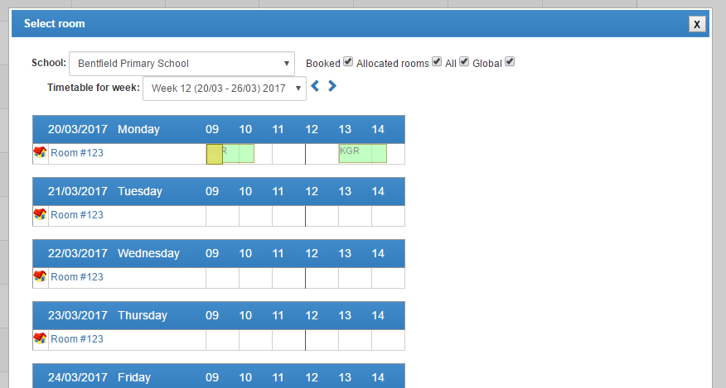

You now see the timetable for the selected room and can find an available slot that fits with your re-scheduled bookings.
Be aware that you have chosen the correct week/date before you drag and drop the bookings into the timetable.
